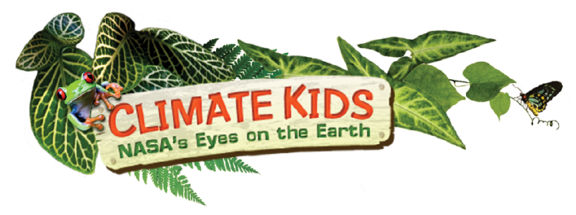
WebQuest

Explore the NASA climate kids website at http://climatekids.nasa.gov/menu/big-questions/ Use the website to answer the questions below.

WHAT IS “GLOBAL CLIMATE CHANGE”?
- What is climate change?

- How is climate different than weather?

HOW DO WE KNOW THE CLIMATE IS CHANGING?
- What is causing climate change?

- Why are rising sea levels a problem?

- How does climate change affect other species

WHAT IS THE BIG DEAL WITH CARBON?
- What are fossil fuels?

- Are happens when we burn fossil fuels? Where does the carbon go?

- Is CO₂ always bad for the earth? Explain.

- What is a greenhouse?

- How is the earth similar to a greenhouse?

- Do clouds make the earth warmer or colder? Explain.

CLIMATE TIME MACHINE
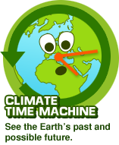
- How much Arctic sea ice has melted just since satellites started observing around 30 years ago?

- What parts of the world will be under water as sea level rises, inch by inch, foot by foot?

- How much has the greenhouse gas carbon dioxide increased in the air just in the last few years?

- How much has temperature risen around the world in just a little over 100 years?

WHAT IS HAPPENING IN THE OCEANS?
- How does the ocean affect the climate?

- Does the salt in the ocean do anything? If so, what does it do?

WHAT CAN WE DO TO HELP?
- How can we help nature?

- How can we reduce our carbon footprint?

- How can I reduce my trash pile?

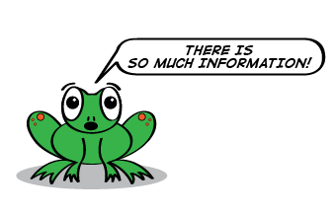

Explore this website. Look at the air, ocean, freshwater, carbon’s travels, energy, plants & animals, and technology pages. Read an article that looks interesting. Write down five new facts that you learned. Earn 1 bonus point for each article you summarize.

