Chapter 1 Lesson 1 The Distant Past

Word | Definition | Picture
Prehistory | The period of time before people began to write; without writing no records could be kept and not stories could be recorded | 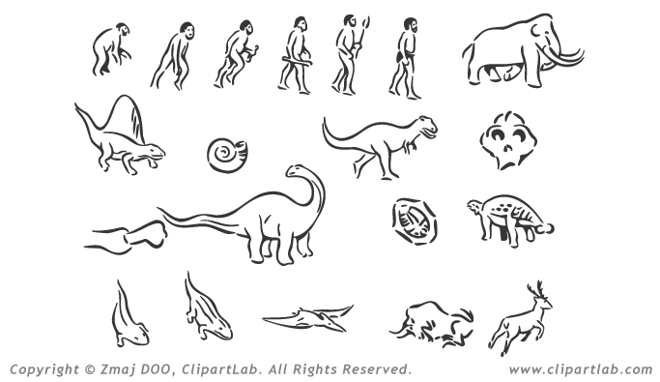
Archeology / Archeologist | Archeology: the study of things that earlier people left behind  Archeologist: a scientist who studies archeology | 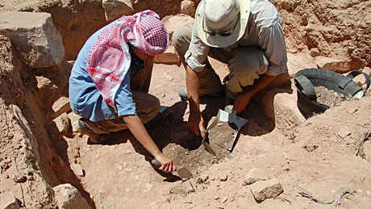
Artifact | Objects made by people. Could be: art, clothing, pottery, tools or weapons | 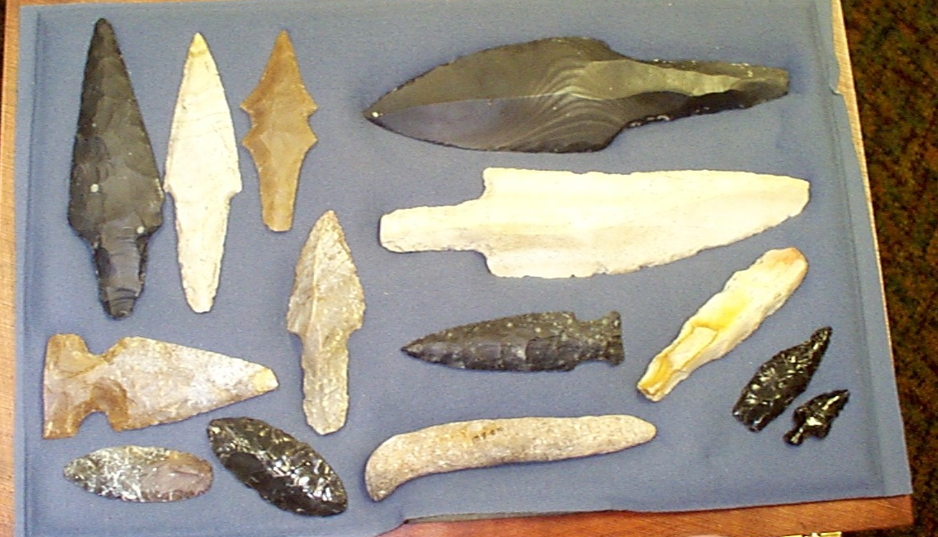
Fossil | Remains, such as bones, of once living animals and humans. Could also be footprints preserved in what is now rock. | 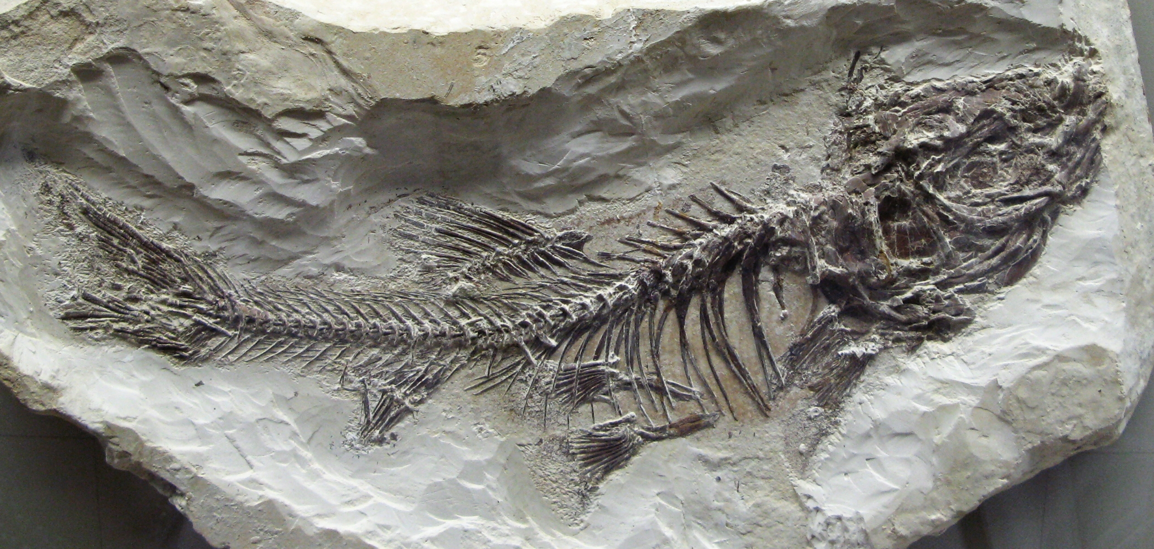
Theory | Accepted explanations, an idea that people believe to be true | 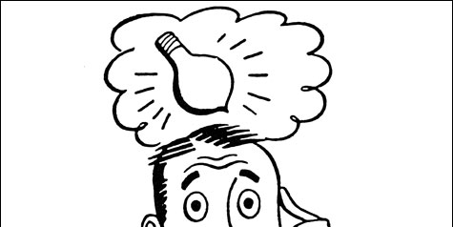

Use the vocabulary words to help you describe how people today learn about the distant past. Write at least 4 sentences.

Archeologists are scientists who study prehistory. They study the period of time before people began to write. Archeologists create theories to explain what life might have been like a very long time ago. They study artifacts and fossils. Studying objects that people left behind and the remains of once living things helps archeologists to create theories about prehistory.

